|  |  |  |  |
| --- | --- | --- | --- |
| **Course Name:** | **Automation and Control Systems lab** | **Semester:** | **V** |
| **Date of Performance:** | **21/08/24** | **Batch No:** | **B1** |
| **Faculty Name:** | **Shila Dande** | **Roll No:** | **16014022050** |
| **Faculty Sign & Date:** |  | **Grade/Marks:** |  |

Experiment No: 4

Title: Study of PLC and Logic gate simulation

|  |
| --- |
| **Aim and Objective of the Experiment:** |
| 1. Learn the basics and hardware components of PLC 2. Study various building blocks of PLC 3. Simulation of logic gates |

|  |
| --- |
| **COs to be achieved:** |
| CO3 : Program PLC for different applications |

|  |
| --- |
| **Theory:** |
| **Evolution of PLC:-**  When the first electronic machine control was designed, relays were to control the machine logic. Relay logic has its own limitations.   1. Less reliability 2. The delay involved in switching of contacts 3. Less flexibility and difficult troubleshooting due to hard wired connection   **What is PLC?**  A Programmable Logic Controller , PLC, or Programmable Controller is an electronic device used for Automation of industrial processes, such as control of machinery on factory assembly lines. A programmable controller is a digitally operating electronic apparatus which uses a programmable memory for the internal storage of instructions for implementing specific functions, such as logic, |

sequencing, timing, counting and arithmetic, to control various machines or processes through digital or analog input/output devices. Unlike general purpose computers, the PLC is designed for multiple inputs and output arrangements, extended temperature ranges, immunity to electrical noise, and resistance to vibrations and impacts.

Programs to control machine operation are typically stored in battery-backed or non volatile memory. A PLC is an example of a real time system since output results are produced in response to input conditions within a bounded time, otherwise unintended operation results.

# Basic Components of PLC:-

1.CPU and Memory module 2.Power supply

1. Input and output module 4.Programming device

# CPU and Memory Module:-

This is the device where PLC program is stored and processed. The size and type of CPU determines the programming functions available, size of the application logic available, amount of memory supported, and processing speed.

# Power Supply:-

The power supply provides power for the PLC system. It provides internal DC current to operate the processor logic circuitry and input/output assemblies. This can be built into the PLC or an external unit. Common voltage levels required by the PLC are 24Vdc, 120Vac, 220Vac. , is used to determine temperature.

# Input and Output Module:-

Inputs carry signals from the field (process) to the controller. Various types of inputs can be switches, pressure sensors, transmitters etc. The field devices to whom PLC sends the results of logical operations are the output devices. These are the actuators that adjusts or control the process,

motors, lights, relays, pumps, etc. Many types of inputs and outputs can be connected to a PLC and they can be categorized mainly as analog and digital. Digital inputs and outputs operate on discrete or binary change i.e. on/off, open/close. Analog inputs and outputs change continuously with reference to time.

# Programming Device:-

The PLC is programmed using a special software using computer or hand Held Terminal(HHT) that can load and change the logic inside.

# Operation of a PLC system:-:

The operation of the PLC is determined by 3 steps.

* 1. Reading the field status form input devices 2.Execution or solving the logic, and 3.Updating the output devices status.

# Implementation of Logic Gates:

**Pre-requisites:-**

Basics of Digital Electronics and Boolean Algebra:

Digitization is a process where continuous analog signal is converted into a finite number of discrete states. These states are well separated so that noise does not create errors.

The resulting digital signal has following advantages:

1. storage over arbitrary periods of time.
2. flawless retrieval and reproduction of the stored information
3. flawless transmission of the information

Some information is essentially digital. Hence it is natural to process and manipulate such information using purely digital techniques. Examples are numbers and words.

The drawback to digitization is that a single analog signal (e.g. a voltage which is a function of time, like a stereo signal) needs many discrete states, or bits, in order to give a satisfactory reproduction.

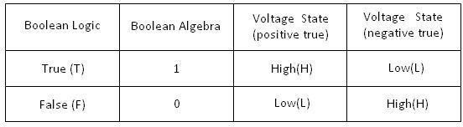

**Logic**

What can a digital circuit do?

The simplest task we can think of is a combinational type of logic decision. For example, we can design a digital electronic circuit to make an instant decision based on some information. Here we emphasize “instant” in the decision making process. That means, the process has no time delay.

, is used to determine temperature.

X = It is a sunny day? Yes

Y = Is it Sunday or holiday? Yes Action Z = Go for shopping

The rule is Z = X and Y. The circuit is a simple AND gate

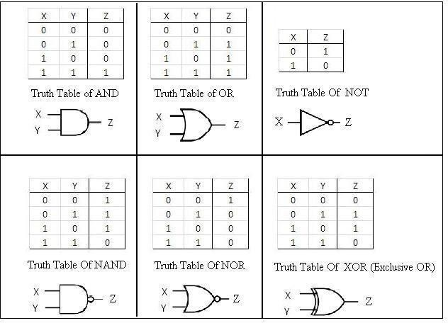

# Boolean Algebra:

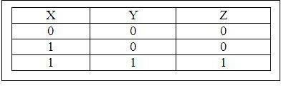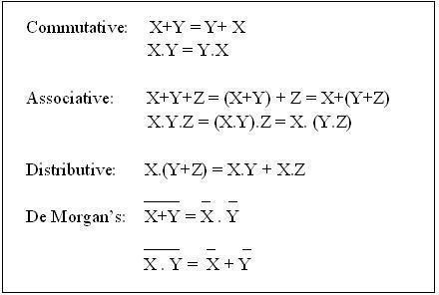

Logic can also be expressed in algebraic form. e.g.Truth Table for AND gate:

Boolean Algebra Simplification:-

# Basic Laws:

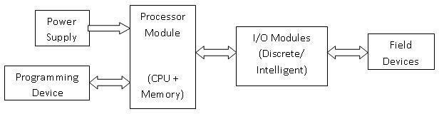

**Circuit Diagram/ Block Diagram:**

|  |
| --- |
| **Stepwise-Procedure:** |
| 1. Open TIA Portal 2. Create New Project 3. Configure New Device 4. Select S7-1200 PLC with the CPU configuration of connected PLC 5. Go to Main Code -> Program Blocks and make the required Ladder Logic 6. Download code to the PLC and switch on Monitoring mode 7. Verify the Ladder logic by toggling controls of PLC and observing on both PLC LEDs and the monitor screen |

|  |  |  |
| --- | --- | --- |
| **Observation Table:** | | |
| AND GATE:    OR GATE: | | |
|  |  |  |

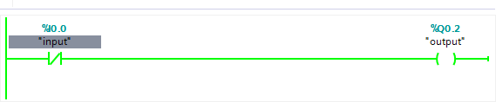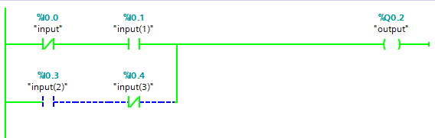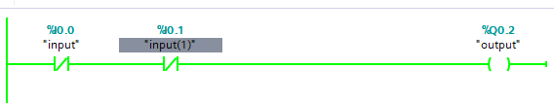

NOT GATE:

NOR GATE:

XOR GATE:

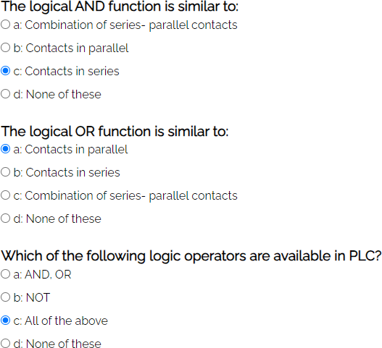

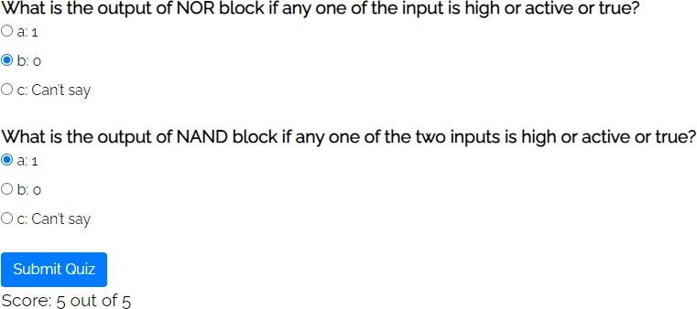

**AND**

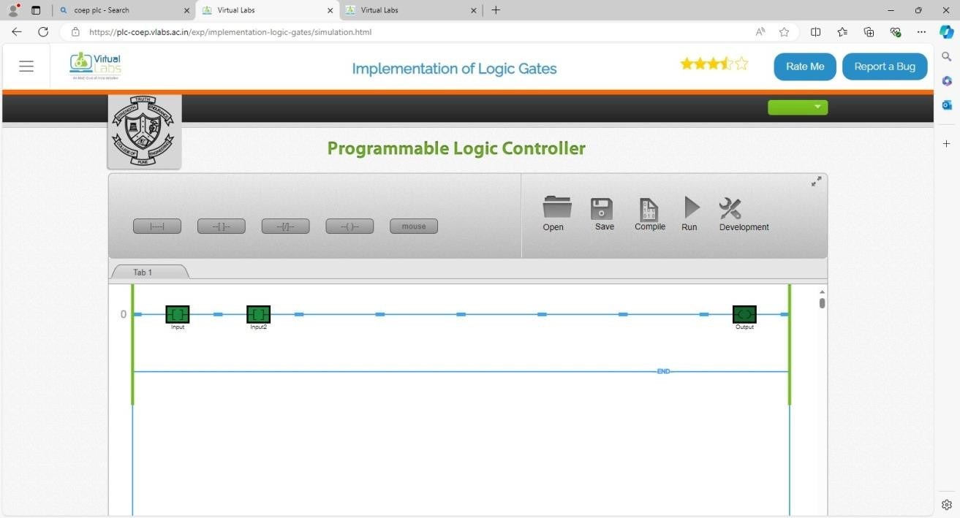

# OR

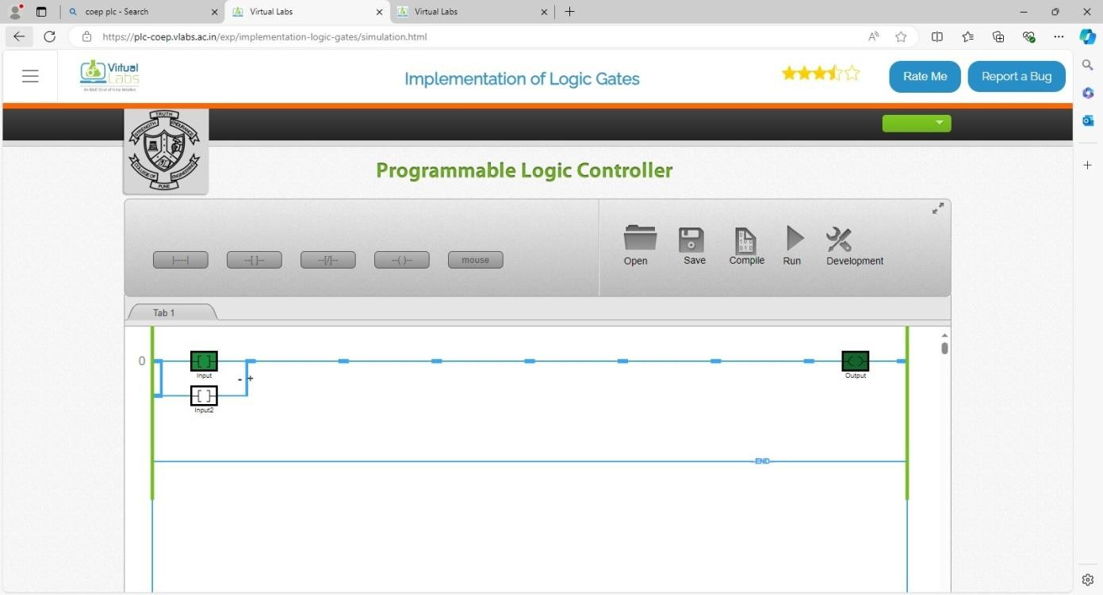

**NAND**

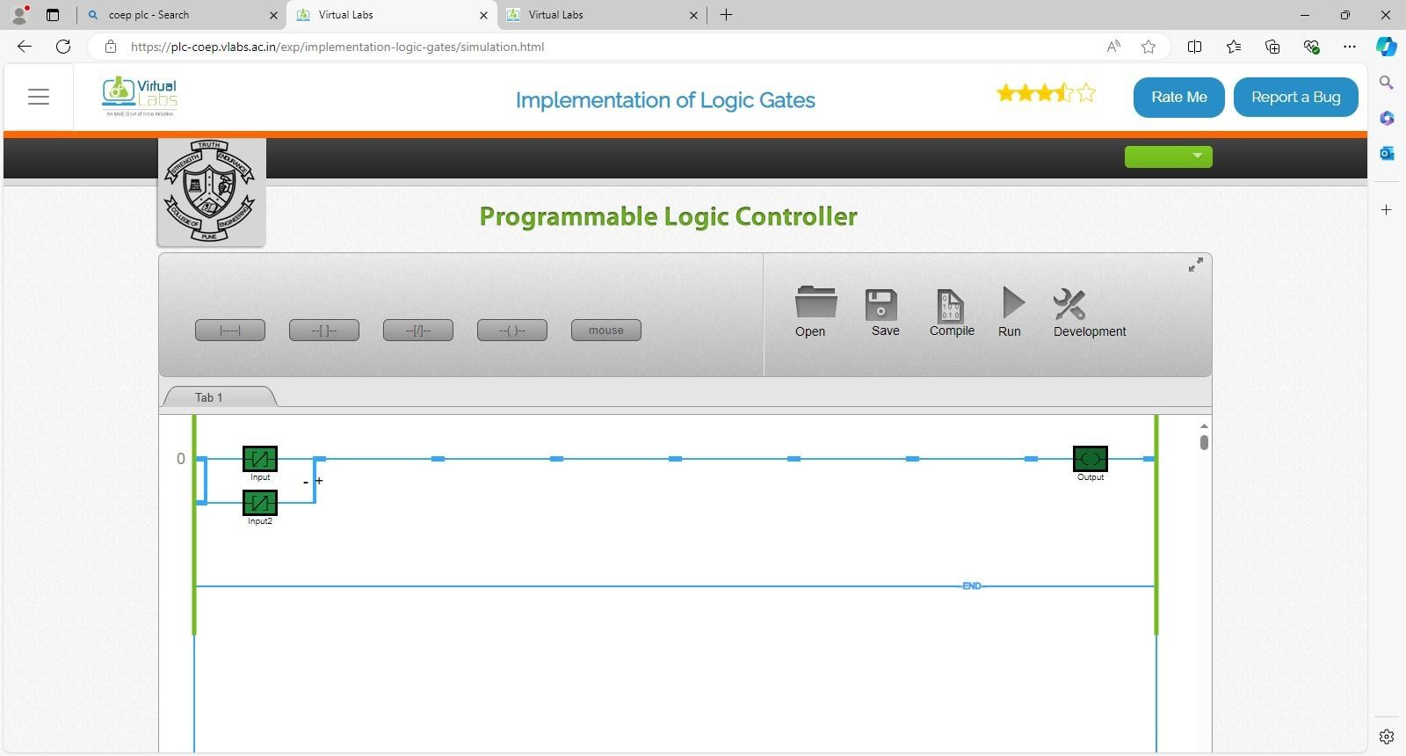

# NOR

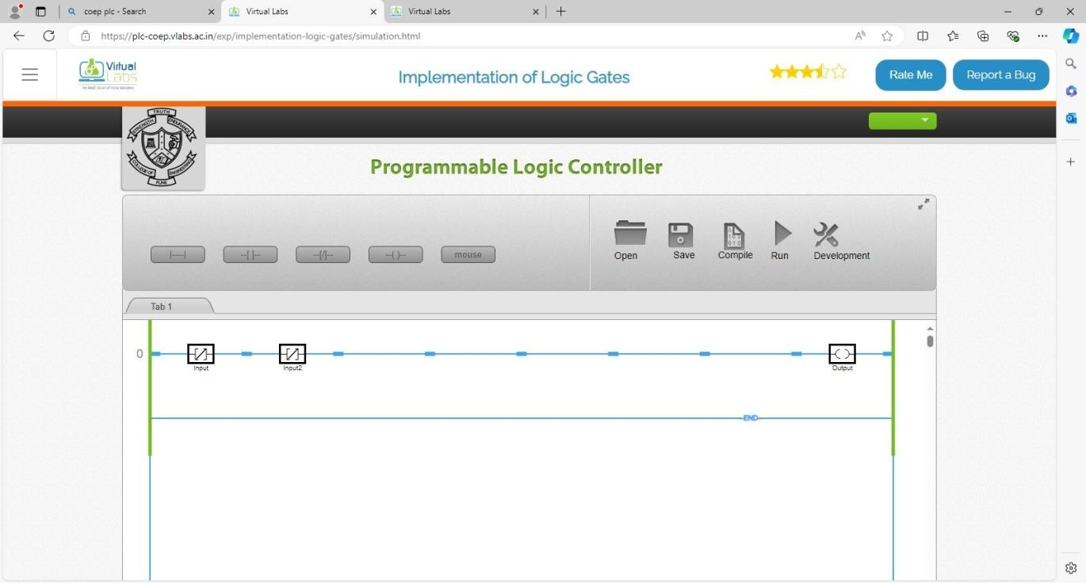

**XOR**

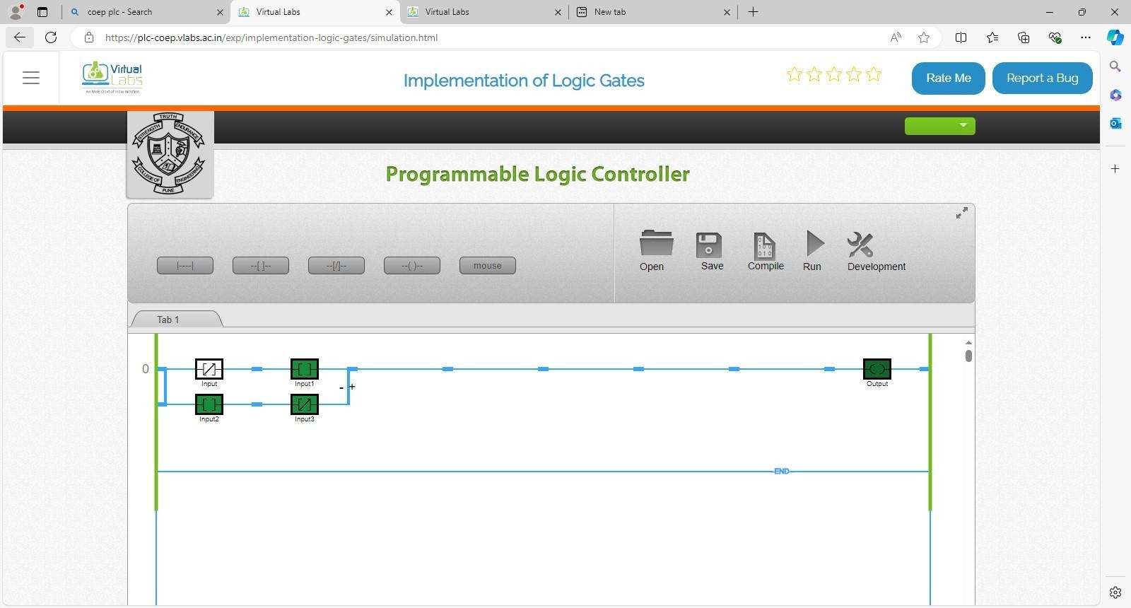

|  |
| --- |
| **Post Lab Subjective/Objective type Questions:** |
| 1. **The PLCs were originally designed to replace**    1. Hardwired relays    2. Analog controllers    3. Microcomputers   **Answer: Hardwired relays** |

# What type of input a limit switch is w.r.t PLc

* 1. Composite
  2. Analog
  3. Digital

**Answer: Digital**

# In a ladder diagram an output would be represented by

* 1. A coil symbol
  2. A closed contact symbol
  3. An open contact symbol

**Answer: A coil symbol**

# When referring to the capacity, the abbreviation K represents locations or words

a) 1000

b) 1024

c) 1036

# Answer: 1024

1. **The basic difference between a PLC and a relay logic is that**
   1. Different types of input/outputs devices are used
   2. Different voltage levels for inputs/outputs are use
   3. One can be programmed other not

# Answer: One can be programmed other not

**Conclusion:** By performing this experiment, I understood importance of Programmable Logic Controllers (PLCs) and their role in industrial automation. By exploring the basic components such as the CPU, power supply, input/output modules, and programming devices we have gained insights into the operational mechanisms of PLCs. The study of PLC evolution highlighted the advantages over traditional relay logic, such as improved reliability and flexibility. Implementing and simulating logic gates emphasized the importance of digital techniques in modern control systems enhancing automation efficiency and process control in various

**Signature of faculty in-charge with Date:**